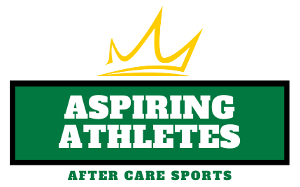

Introducing Aspiring Athletes, an Optional Add-On for Crown After Care.

Crown Sports Center is proud to announce its newest offering for young sports enthusiasts: The Aspiring Athletes after care add-on program. Designed to provide a safe and engaging environment for children, this program offers a unique opportunity for participants to explore and develop their skills in a variety of sports. With a focus on a different sport each month, Aspiring Athletes aims to foster a love for physical activity, teamwork, and healthy competition in a fun and supportive setting.

- Monthly Sports Focus: The Aspiring Athletes program rotates through a diverse range of sports to provide participants with exposure to different athletic disciplines. The featured sports include soccer, baseball and softball, football, lacrosse, and basketball. Each month, children will have the chance to learn the rules, techniques, and strategies specific to the highlighted sport.
    - September – Baseball/Softball
    - October – Soccer
    - November – Lacrosse
    - December – Basketball
    - January – Soccer
    - February – Lacrosse
    - March – Basketball
    - April – Baseball/Softball
    - May - Soccer
- After Care: Children are eligible to register for Aspiring Athletes if they are in the Crown After Care Program. This is an “Add-On” of $30 per week and your child will participate in the sports instruction and game play from 4-5pm, Monday – Friday.
- Engaging Activities: Aspiring Athletes go beyond basic childcare by offering engaging activities that promote physical fitness, motor skills development, and sportsmanship. Under the guidance of experienced and enthusiastic coaches, participants will have the opportunity to refine their abilities, improve their coordination, and build confidence in their athletic capabilities.
- Safe and Supportive Environment: Crown Sports Center prioritizes the safety and well-being of every child. The Aspiring Athletes program ensures a secure environment where children can freely express themselves, learn new skills, and make lasting friendships. The program adheres to all necessary safety protocols, including proper equipment usage and age-appropriate activities.
- Affordable Pricing: We believe in making high-quality sports programming accessible to all families. The Aspiring Athletes after care add-on is competitively priced at $30 per week, providing exceptional value for the comprehensive sports instruction and care offered.

Enrollment:
To enroll your child in the Aspiring Athletes program, please visit www.crownsportscenter.com or contact Mandy Schuyler at 410-742-6000. Limited spots are available, so we encourage early registration to secure your child's place in this exciting program.

Join us at Crown Sports Center's Aspiring Athletes Before and After Care Program, where children can explore the world of sports, cultivate new skills, and have a blast in a safe and supportive environment. Our goal is to inspire a lifelong love for physical activity and empower the next generation of athletes.

